

PROJECT :- “ CALENDER WEBSITE”
Submitted by :- Submitted to:-
Reg :- 11906052 Shabnam
Roll no. :- 16
Reg :-11900167
Roll no. 17
Reg :- 11916794
Roll no :- 42

CONTENTS

* ABSTRACT OF PROJECT

* INTRODUCTION

* WEBSITE DESIGNING

* CONCLUSION

ABSTRACT OF PROJECT

Calendar+ is an android application which accesses the calendars of multiple users, for instance members of a family or staff in a particular department and will pull out the events from every calendar. Hence, everyone in the group can see others’ events on one screen in customized format. It also helps the user to create, edit, and delete events of his/her calendar. Additionally, this application will use an efficient strategy to update data only if there is any change in the events, making it faster. There are many other applications in the Play store but they cannot get rid of redundant events and reminders of events belonging to other users. This causes a lot of disturbance to the user. On the contrary, Calendar+ application will use an intelligent algorithm to compare the events in many ways based on the time, name, and place of event. Furthermore, this application will only generate reminders for the user events.

Introduction
A calendar is a system of organizing units of time for the purpose of reckoning time over extended periods. By convention, the day is the smallest calendrical unit of time; the measurement of fractions of a day is classified as timekeeping. The generality of this definition is due to the diversity of methods that have been used in creating calendars. Although some calendars replicate astronomical cycles according to fixed rules, others are based on abstract, perpetually repeating cycles of no astronomical significance. Some calendars are regulated by astronomical observations, some carefully and redundantly enumerate every unit, and some contain ambiguities and discontinuities. Some calendars are codified in written laws; others are transmitted by oral tradition.

The common theme of calendar making is the desire to organize units of time to satisfy the needs and preoccupations of society. In addition to serving practical purposes, the process of organization provides a sense, however illusory, of understanding and controlling time itself. Thus calendars serve as a link between mankind and the cosmos. It is little wonder that calendars have held a sacred status and have served as a source of social order and cultural identity. Calendars have provided the basis for planning agricultural, hunting, and migration cycles, for divination and prognostication, and for maintaining cycles of religious and civil events. Whatever their scientific sophistication, calendars must ultimately be judged as social contracts, not as scientific treatises.

WEBSITE DESIGNING

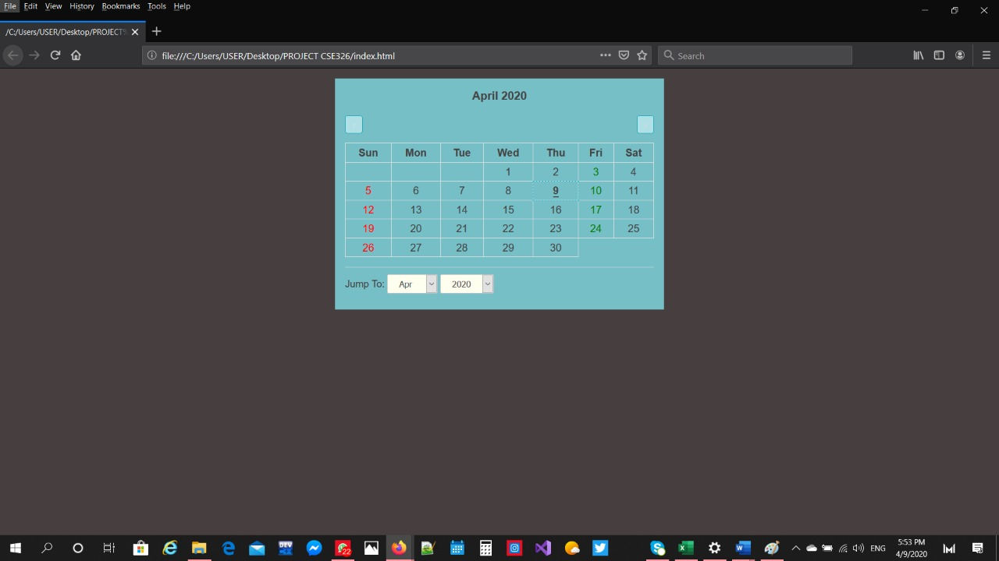

- HTML :-
Hypertext Markup Language(HTML) is the standard markup language for documents designed to be displayed in a web browser.
HTML stands for Hypertext Markup Language. It allows the user to create and structure sections, paragraphs, headings, links, and blockquotes for web pages and applications.
- Tags use in html :-

<!DOCTYPE> :- Defines a document type.
* The root element is ...
<html> :- Define a document is a HTML markup language .
<head> :- Defines header section of HTML document .
<body> :- Defines a main section(body) part in HTML document.
<a> :- Specific a anchor (Hyperlink) Use for link in internal/external web documents.
<br/> :- Specific a single line brea
<button> :- Specifies a press/push button
<h1>to<h6> :- Defines a Headings level from 1 to 6 different
sizes.
<img>: Used to insert image into a web document.
<font> :- Changes font att ributes for text within the tags
* Tabular data is.....
<table> :- Generates a table
<col> :- Sets attributes for columns
<td> :- Defi nes a table data cell
<th> :- Defi nes a table header with bold, centered table data
<from> :- Generates a container for all form element
<div> :- Generic container for blocks of text
<sup> :- Texto en superíndice
<area> :- Sector in an image map
<caption> :- The caption of a table
<option> :- An option in list

(Responsibility by - Raj singh(roll-16))

- JAVASCRIPT

JavaScript, often abbreviated as JS, is a programming language that conforms to the ECMAScript specification. JavaScript is high-level, often just-in-time compiled, and multi-paradigm. It has curly-bracket syntax, dynamic typing, prototype-based object-orientation, and first-class functios

- HTML script tags …..............
- The <script> tag is used to define a client-side script (JavaScript).
If the "src" attribute is present, the <script> element must be empty
The <script> tag also supports the Global Attributes in HTML.

* Default CSS Settings
Most browsers will display the <script> element with the following default values:

(Responsibility by - Tirtha Sanyal(roll-17))
* CSS

CSS stands for Cascading Style Sheets with an emphasis placed on “Style.” While HTML is used to structure a web document (defining things like headlines and paragraphs, and allowing you to embed images, video, and other media), CSS comes through and specifies your document’s style—page layouts, colors, and fonts are all determined with CSS. Think of HTML as the foundation (every house has one), and CSS as the aesthetic choices (there’s a big difference between a Victorian mansion and a mid-century modern home).

align-content | Specifies the alignment of flexible containers items within the flex containers.
Background-color | Define an always background color
Background-image | define an element background image
Background-size | Specifies the size of background image
Border-image-source | Specifies the location of image where border is used
font | Defines a variety of font properties within one declaration.
Padding-left | Sets the padding to the left side of the element
Padding-right | Sets the padding to the right side of an element.
Text-align | Sets the horizontal alignment of inline content.
Word-spacing | Set the space between words.
Max-height | Specify the maximum height of an element.
Font-size | Defines the font size for the text.
height | Specify the height of an element.
left | Specify the location of the left edge of the positioned element.
margin | Sets the margin on all four sides of the element.
resize | Specifies whether element is resizable or not
Vertical-align | Sets the vertical positioning of an element relative to the current text baseline.

(Responsibility by- Hamzahmohammed(roll-42))

CONCLUSION

